# Google ads

<https://www.storegrowers.com/set-up-google-ads/>

<https://www.youtube.com/watch?v=EeF0yWP4xp0&ab_channel=JasonWhaling>

<https://neilpatel.com/what-is-google-adwords/>

<https://blog.hubspot.com/marketing/google-adwords-ppc>

<https://www.reddit.com/r/adwords/comments/6uagha/setting_up_first_adwords_campaign_am_i_doing_this/>

* The most important thing in AdWords is keyword selection

<https://www.reddit.com/r/PPC/comments/6qqcc9/new_ultimate_adwords_guide_8_things_youre_gonna/>

Keywords - words or phrases that people type into Google Search (look for frequently used keywords)

Bid – How much you are willing to pay for an ad

Quality Score – relevance of keywords

## Deciding on which funnel to focus on

Source: <https://adespresso.com/guides/google-ads-beginners/keywords-research/>

**You want a mix of high and low volume keywords**

Generally speaking, most keywords with higher average monthly searches will have more competition. But they will also be more general in nature, leading to fewer sales.

Having a mix of both will give you specificity and tons of traffic that you can remarket.

The key with keywords (pun intended) is to analyse intent behind the search.

Always analyze the intent behind a keyword before you run with it.

Match keywords directly to your campaign goals.

If you want to sell more shoes in this campaign, focus on keywords that are lower in the funnel. If you want to educate people about your shoe brand, target top of the funnel review searches.

After compiling a big list of potential keywords using the keyword tool, you can move on to using a few more tools that can help you dig deeper into potential ideas by investigating your competition.

## How to use third party tool to spy on the competitor’s keywords

The keyword planner is a great start to generate basic ideas and get a feel for keyword research.

But nothing beats spying on competitors and seeing what keywords they target and find success with.

**If you aren’t sure who your competition is, conduct a basic search on Google for a keyword that you found using the keyword planner:**

## List of online tools

1. Keywordtool.io
2. Spyfu.com
3. SEMrush

## Good links

1. Storegrowers - https://www.storegrowers.com/keyword-research-google-ads/
2. Adspresso – https://adespresso.com/guides/google-ads-beginners/keywords-research/
3. <https://www.ppchero.com/how-to-address-low-search-volume-keywords-in-google-ads/>
   1. How to address low keyword search volume
4. <https://neilpatel.com/blog/7-deadly-adwords-mistakes-thatll-make-you-broke-and-how-to-fix-them/>
5. <https://support.google.com/google-ads/answer/7337243?hl=en-GB#zippy=%2Ca-get-ideas-for-new-keywords>
6. [Call Out Extensions ideas](https://www.buildupbookings.com/blog/list-of-callout-extension-examples/)

* w

Bidding on competitors can influence search and even drive sales. Competitors campaigns are usually some of my best campaigns for a client outside of brand terms. I'd keep low volume search terms if they are relevant and I have the budget.

* w

# Keyword analysis

Original organic SEED keywords

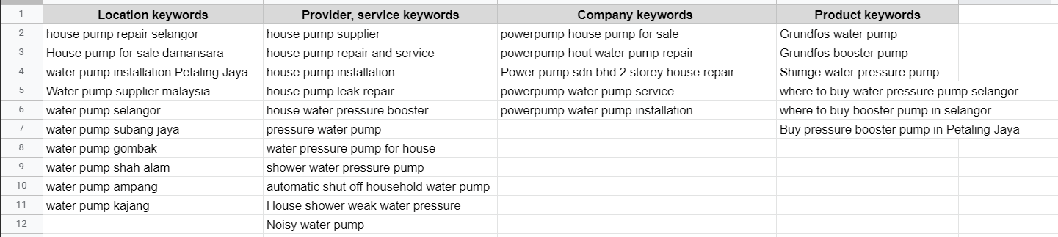

## Services keywords

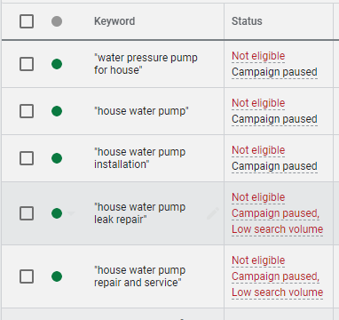

V1

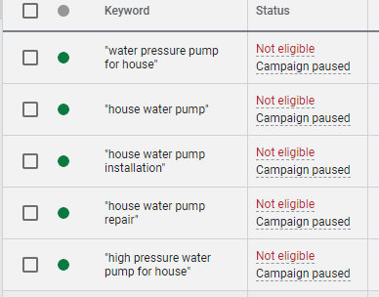

## Product keywords

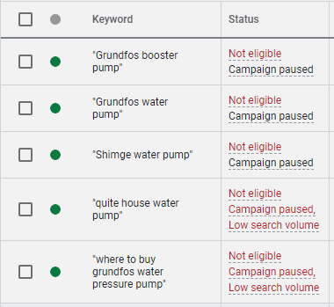

V1

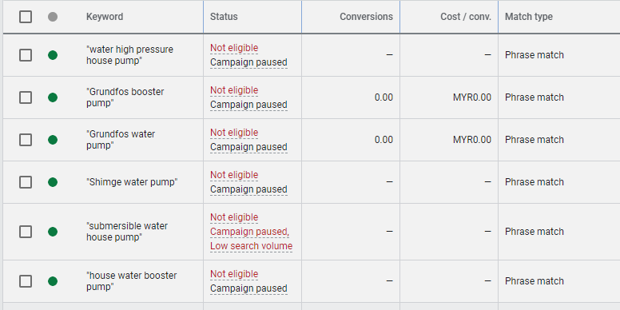

## Location keywords

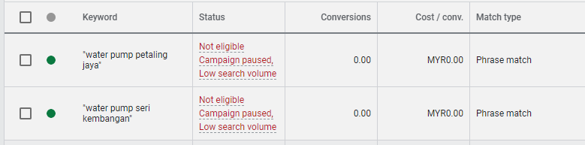

Very low search volume for these two, should we still include or, I think people would search like this right for pumps in their area

Testing

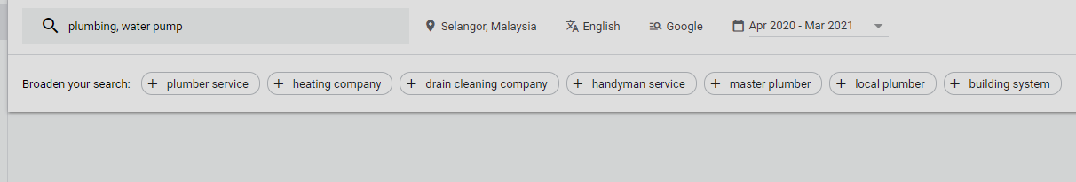

# Questions

1. Newly added keyword – “House Booster Pump” (AD is not showing up)
   1. No “house Booster Pump” keyword in landing page
      1. <https://waterpump.puregen.com.my/?gclid=EAIaIQobChMIjtzWzfGa8AIVhsFMAh0MnwNpEAAYASAAEgJ9ifD_BwE>
      2. This website is showing up in the first ad and they do not have “house booster pump” anywhere – bidding or we have to wait a little longer
   2. Newly added keyword is still processing under google

To be further reviewed

